Test Plan

The test plan is a document for performing manual regression testing on the e-commerce website, **saucedemo.com**, which allows users to perform some actions through an online shopping cart. This test plan is to ensure that existing functionality is not broken when new features/changes are implemented. After changes to the website, including UI changes, backend updates, core functionalities must be executed.

Test Strategy

Functional testing:

* We have to test the core functionalities of the website like adding items/removing items from the cart, checkout process, search, filters dropdown list functionality, quantity updating, order confirmation page and the payment page.
* Mandatory input fields should be verified. If invalid/empty data is provided, appropriate error message should be displayed.

UI testing:

* Test all the UI elements including links, forms, buttons, images, dropdowns, search bar, payment details UI
* Ensure to validate cross browser testing to check the compatibility like chrome, safari, IE, Firefox etc.
* Validate the different devices like iphone, ipad, tablets, android or Browser stack to ensure compatibility across devices.

Backend testing:

* Mainly focus on testing login, payment processing and logout functionality
* Test if the data is fetching correctly from the database like Item price, item quantities, username & password and other product list items (product name, description, image etc.)

Performance testing:

* Check the performance of the site if multiple users are handling at the same time
* Validate whether the site is responding quickly and also it should not go down even though load increases.

Security testing:

* Ensure that the information about card details, user credentials should be confidential
* We can also validate alert popup, which is displayed if the user cannot complete the transaction within the time
* Validate whether the user is logged out automatically after the specified session time.

Core Test Cases of Regression Testing:

Test Scenario 1: Verify Login/Logout Functionality and Homepage

|  |  |  |  |
| --- | --- | --- | --- |
| Test Case ID | Actual Result | Expected Result | Automation |
| 01 | Launch the site saucedemo.com | User launched the site successfully | Yes |
|  | Verify if user able to see username and password | Fields are displayed as expected |  |
|  | Validate the error messages are displaying if user did not enter any credentials | Appropriate errors messages should be displayed |  |
|  | Validate the login functionality with the correct credentials | User able to login successfully |  |
|  | Validate whether the homepage is loading with all the product listings | Homepage loads correctly as expected |  |
|  | Validate all the product item links are working fine and navigating to respective pages or not | All the links should work and user should navigate to respective pages |  |
|  | Verify all the product details are displaying correct like name, price and description | All the product details should be displayed as expected |  |
|  | Validate if the user is logged out from the site or not | User able to logout successfully |  |

Test Scenario 2: Validate Add to cart functionality

|  |  |  |  |
| --- | --- | --- | --- |
| Test Case ID | Actual Result | Expected Result | Automation |
| 02 | Launch the site saucedemo.com | User launched the site successfully | Yes |
|  | Verify if user able to see all the products with “Add to cart” button and verify if it is clickable | Button should be displayed and it is clickable |  |
|  | Verify whether the item is added to the cart when the user clicks on Add to cart button. | The item should be added to the cart successfully |  |
|  | Validate whether Remove button is displaying or not after user added the item to the cart. | The button should display the remove option as expected |  |

Test Scenario 3: Validate the order details page

|  |  |  |  |
| --- | --- | --- | --- |
| Test Case ID | Actual Result | Expected Result | Automation |
| 03 | Launch the site saucedemo.com | User launched the site successfully | Yes |
|  | Verify whether the selected items are added to the cart | Selected items are added to the cart successfully |  |
|  | Validate checkout button is displayed and verify if it is clickable | It is displayed as expected and the user is able to navigate to the checkout page |  |

Test Scenario 4: Validate the payment processing functionality

|  |  |  |  |
| --- | --- | --- | --- |
| Test Case ID | Actual Result | Expected Result | Automation |
| 04 | Launch the site saucedemo.com | User launched the site successfully | Yes |
|  | Verify if the user is able to add the items to the cart | Selected items are added to the cart successfully |  |
|  | Validate checkout button is displayed and verify if it is clickable | It is displayed as expected and the user is able to navigate to the checkout page |  |
|  | Validate if the user is able to see the total price | User should be able to see the total price as expected |  |
|  | Validate whether appropriate error messages are displaying or not if the user clicks on proceed button without giving valid input data | Appropriate error messages should be displayed as expected |  |
|  | Validate whether the user is able to enter the card details and verify if the payment is successful | User should be able to enter the details and the payment is successful |  |
|  | Validate if the user received the confirmation email after the completion of the payment | User should receive the order confirmation email. | No |

Test Scenario 5: Validate cross browser compatibility and multiple device compatibility

|  |  |  |  |
| --- | --- | --- | --- |
| Test Case ID | Actual Result | Expected Result | Automation |
| 05 | Launch the site saucedemo.com | User launched the site successfully | No |
|  | Validate the UI functionality of the site in the mentioned browsers Chrome Edge Safari Firefox | UI should be displayed correctly across all browsers |  |
|  | Validate whether the site is aligned properly in the different devices like iphone, ipad, android etc.. | Site should be aligned properly across different devices as expected |  |

Defects :-

With locked_out_user

Bug ID : 1

Issue Description: login credentials are locked

Severity: Block

Priority: High

Steps to Reproduce:

* Enter the username and password

Actual Result:

* User is unable to login to the website

Expected Result:

* User should be log in to the site without any issues

Status: New

Assigned to: Developer

Attachments:

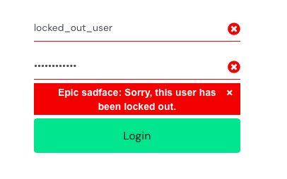

With problem_user

Bug ID : 2

Issue Description: Add to cart/Remove button is not working properly in product and product detail page.

Severity: Critical

Priority: High

Steps to Reproduce:

* Login to the site
* Click on the add to cart button

Actual Result:

* User is not able to perform the action on Add to cart button

Expected Result:

* Add to cart Button should work properly if user clicks on it

Status: New

Assigned to: Developer

Attachments:

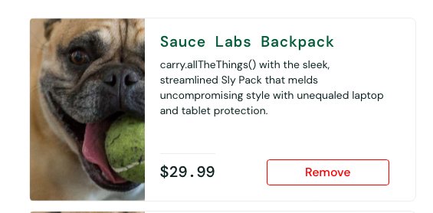

Bug ID : 3

Issue Description: Dropdown filters are not working in the product listing page

Severity: Critical

Priority: High

Steps to Reproduce:

* Login to the site
* Click on the dropdown and try to select the options

Actual Result:

* Dropdown values are not able to select and the search results are not populating as expected

Expected Result:

* User should be able to select the dropdown filters and see the search results accordingly

Status: New

Assigned to: Developer

Attachments:

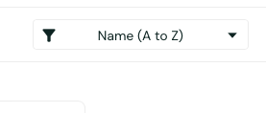

With performance_glitch_user

Bug ID : 4

Issue Description: Performance of the site is too slow

Severity: Major

Priority: Medium

Steps to Reproduce:

* Login to the site
* Perform any action of the items

Actual Result:

* Site performance is very slow if user perform any action

Expected Result:

* Site should be able to respond quickly if user perform any action on the site

Status: New

Assigned to: Developer

Attachments:

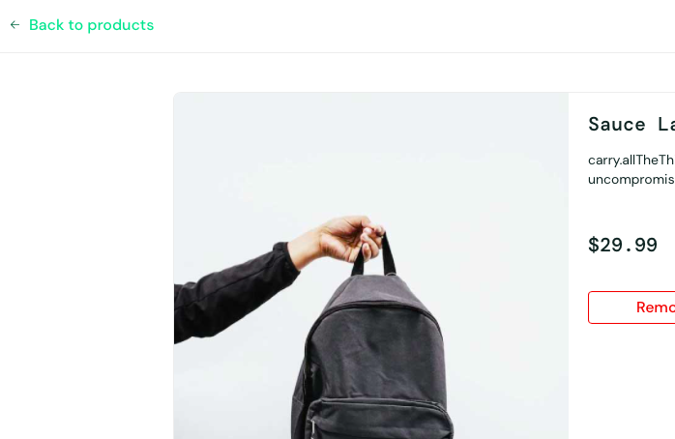

With error_user

Bug ID : 5

Issue Description: user clicks on Dropdown filters its displaying error popup

Severity: Critical

Priority: High

Steps to Reproduce:

* Login to the site
* Click on the dropdown and try to select the options

Actual Result:

* Pop-up is displaying with the error message when the user selects any option in the dropdown filters.

Expected Result:

* User should be able to select any option in the dropdown filters and see the respective results as expected

Status: New

Assigned to: Developer

Attachments:

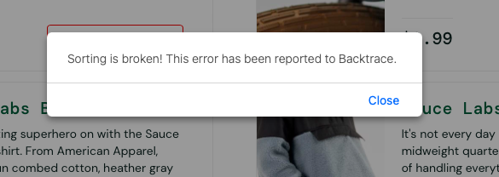

With visual_user

Bug ID : 5

Issue Description: Ui of the site is not properly aligned

Severity: Minor

Priority: Low

Steps to Reproduce:

* Login to the site
* Check all the elements are properly aligned including images, text, icons etc..

Actual Result:

* UI is not displaying properly

Expected Result:

* UI should be displayed properly

Status: New

Assigned to: Developer

Attachments:

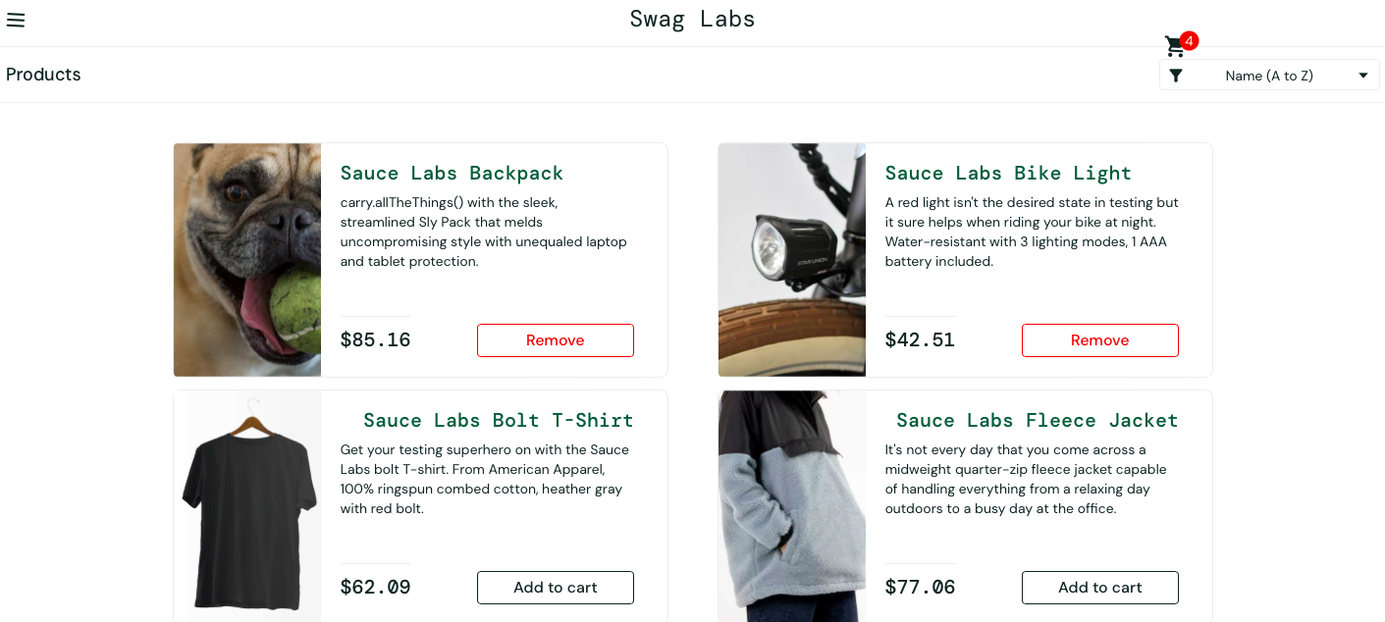

Queries:

1. Search bar and search button is not displaying on the site

2. There is no option to increase /decrease the quantity of a single item

3. Order details page is not displaying.

4. In checkout page, payment fields are not displaying to proceed for the payment.